 

**Strikers BBL Academy Application Process**

**Information for Prospective Cricketers**

Successful applicants will be provided with an opportunity to prepare and progress to a higher level of T20 cricket in a program that will run from July 2025 until April 2026.

The aim is for players to successfully transition from Youth Pathways & Premier cricket into T20 cricket and to contribute to the Strikers winning games of BBL T20 cricket.

Ultimately the success of this program will be driven by the players desire to succeed at the next level.

Five key elements will combine to underpin the fundamentals of the Strikers BBL Academy program.

|  |  |
| --- | --- |
| Technical | Access to private 1 on 1 and/or small group coaching sessions |
| **Tactical** | Access to a mentor coach who can assist the player become better equipped at understanding the nuances of the game and how they can become BBL T20 players who can contribute to team success |
| **Physical** | Access to a suite of Sports Science / Sports Medicine programs such as Strength & Conditioning, Physiotherapy & Dietary |
| **Psychological** | Access to a performance mindset coach |
| **Play** | Various playing opportunities in challenging conditions throughout the year  *Selection in any games is derived from Premier Cricket performances |

**Selection Criteria**

The selection of players into the Strikers Academy program considers the following criteria:

1. A maximum of eight (8) players are to be selected.
2. To be eligible for selection in the Strikers Academy, players are required to be currently **uncontracted** to any BBL and/or State Men’s senior program, and to not be a member of any other SACA representative squad (e.g. SACA U19’s, SACA State Academy etc.)
3. Selected players must be able to demonstrate performance and character traits required to enable them to have the best chance of developing into future BBL T20 players capable of contributing to the Adelaide Strikers winning games of cricket.

**Players are expected to.**

* Demonstrate a willingness, desire, and commitment to develop their own skills and knowledge of the game.
* Provide a positive role model for others in their approach to learning and behaviour on and off the field.

**Application Process:**

|  |  |
| --- | --- |
| 1. | Complete the Strikers BBL Academy application form (see below) |
| **2.** | Provide a written reference from a cricket coach who is familiar with you and/or has coached you. (The player) |
| **3.** | Submit your application form and reference prior to the due date **(Friday 6 June 2025)** to John Palmer via email [jpalmer@saca.com.au](mailto:jpalmer@saca.com.au) |
| **4.** | Applications will be reviewed, and successful applicants (only) will be contacted by SACA Cricket Department staff prior to COB on **Friday 13 June 2025** |
| **6.** | Induction: **Monday June 30** |
| **7.** | Skills & S&C Program Commences: **Tuesday July 1** |
| **8.** | Northern Territory Tour (if selected): **14 -24 August 2025 (TBC)** |
| **9.** | Further in-season training and playing program: (**TBC)** |

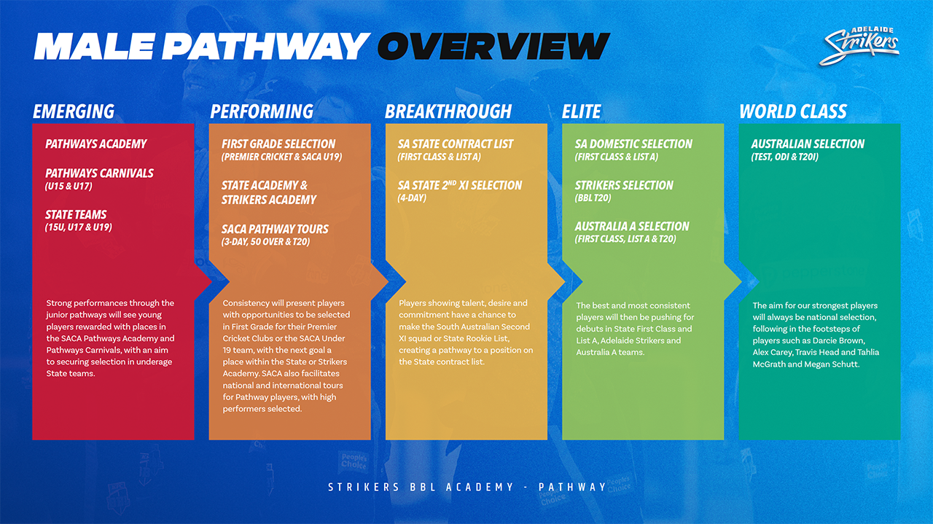

**Strikers BBL Academy Application Form**

|  |  |
| --- | --- |
| Given Name |  |
| **Surname** |  |
| **Date of Birth** |  |
| **Gender** |  |
| **Street Address** |  |
| **Suburb** |  |
| **Postcode** |  |
| **Email** |  |
| **Phone** |  |
| **Current School** |  |
| **Current University** |  |
| **Current Work** |  |
| **Allergies** |  |
| **Current Club** |  |
| **Parent/Guardian**  **(Emergency Contact)** |  |
| **Name** |  |
| **Address** |  |
| **Phone** |  |
| **Email** |  |

**In your own words, please tell us why you should be included in the Strikers BBL Academy program?** *(Please include relevant previous season statistics in your answer).*

* I understand that by signing this document and declaration that this constitutes my full commitment to being involved in the Strikers BBL Academy program should my application be successful.
* I declare that the information provided in this application is, to the best of my knowledge, accurate and complete. I recognise that, should statements in this application prove to be false or misleading, any decision made as a result of this application may be reversed.

**Signed by:**

Print Name:

Date:

**In the presence of (witness)**

Print Name:

Date: